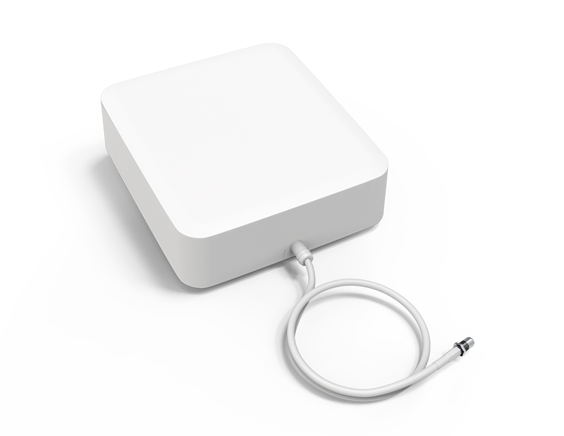
PANEL DIRECTIONAL ANTENNA
OP0838-0665
Features：
- Wide band design, 806~960/1710~2700/3300~3800MHz
- Simple installation & stable performance
- Good anti-vibration and aging resistance
- Small size and light weight
- Outdoor wall mounting or Hold pole installation

Specification：
Frequency | 806~960/1710~2700/3300~3800MHz
Bandwidth | 154/990/500MHz
Gain | 6~8dBi
VSWR | ≤ 1.8
Max. power | 50W
Impedance | 50Ω
Polarization | Vertical
Horizontal Beamwidth | 115/75/95°
Vertical Beamwidth | 65/60°
Front to Back Ratio | ≥ 15dB
PIM3 | ≤ -120dBc
Rated Wind Velocity | 60m/s
Lightning Protection | DC Ground
Weight | ≤ 0.7kg
Color | White
Operating Temperature | -10℃~+55℃
Dimension | 165×155×65mm
Connector Type | SMA-Female or customized
Terminal line | White 3D-FB, L=300mm
Radiating Element Material | Aluminum Alloy
Radome Material | UV-Resistance ABS
Accessories for installation | Hold pole installation

The Picture mentioned above is for reference only, and subjects to Amplitec’s final confirmation.

